Assignment 3
- Locate the DNS query and response messages. Are they sent over UDP or TCP?
Ans1. DNS query and response messages:
DNS query:
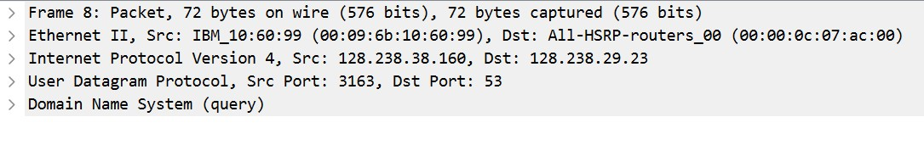
DNS response:
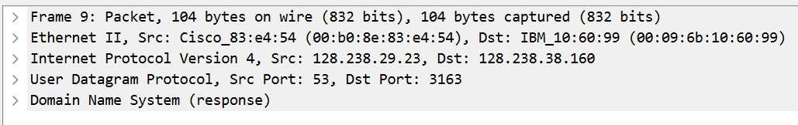
They both use UDP protocol.
2..What is the destination port for the DNS query message? What is the source port of DNS response message?
Ans2.

The dst port DNS query is 53.

The src port for DNS response 53.

3.To what IP address is the DNS query message sent? Use nm-tool command to determine the IP address of your local DNS server. Are these two IP addresses the same?
Ans3. DNS query is sent to 128.238.29.23. My local machine’s DNS server is 10.58.215.97 These are not same.
4.Examine the DNS query message. What “Type” of DNS query is it? Does the query message contain any “answers”?
Ans4. It is a Type A Class IN query.
It does not contain any answers.
5.Examine the DNS response message. How many “answers” are provided? What do each of these answers contain?
Ans 5. There are two answers in DNS response.
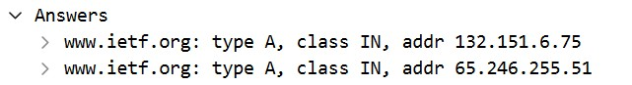

The answers contain the IP addresses to which the domain name www.ietf.org is mapped..
6.Consider the subsequent TCP SYN packet sent by your host. Does the destination IP address of the SYN packet correspond to any of the IP addresses provided in the DNS response message?
Ans6. Yes the SYN packet corresponds to the IP address 132.151.6.75 which was in the DNS response.
7.This web page contains images. Before retrieving each image, does your host issue new DNS queries?
Ans7. No, the host does not issue new DNS queries for retrieving each image because all images are retrieved from the same domain, so the resolved IP is cached in the browser and there is no need of getting the IP address again.

Part 2:
8. To what IP address is the DNS query message sent? Is this the IP address of your default local DNS server?

Ans8. The DNS query is
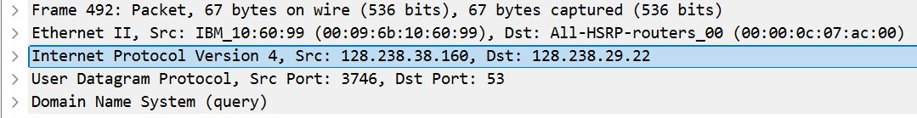
It is sent to the IP address 128.238.29.22.
The IP address of my local DNS server is 10.58.215.97.
No it is not same.
9. Examine the DNS query message. What “Type” of DNS query is it? Does the query message contain any “answers”?

Ans9. It is of the type NS and class IN.
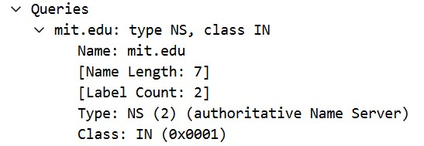
It does not contain any answers.
10.Examine the DNS response message. What MIT nameservers does the response message provide? Does this response message also provide the IP addresses of the MIT nameservers?
Ans10. The name servers provided by DNS response are:
Yes the response also has their IP addresses in the additional records:

